Parkhurst Road, Bexley, Kent, DA5 1AX
Tel: +44(0)1322 524544
Email: club.manager@bexleyclub.co.uk
www.bexleyclub.co.uk

APPLICATION FOR MEMBERSHIP 2024/25
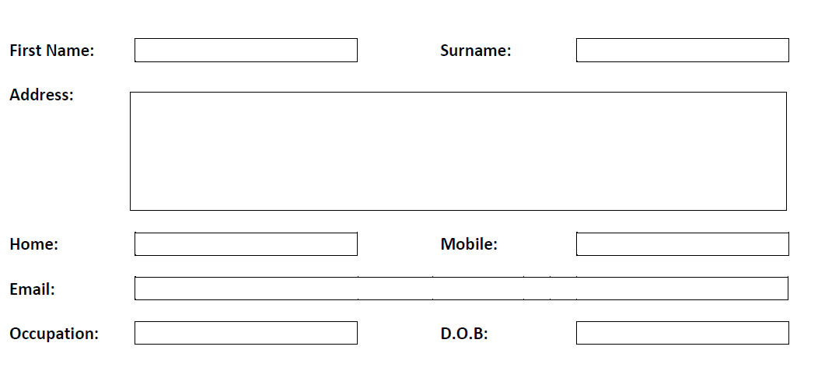
(Please print clearly)

*Family Tennis and Squash/Racketball | £845.00 |  | 18-29 Yrs Tennis | £245.00
*Family Tennis | £749.00 |  | 18-29 Yrs Squash/Racketball | £180.00
*Family Squash/Racketball | £605.00 |  | Junior/Student Tennis and Squash/Racketball | £74.00
Adult Tennis and Squash/Racketball | £410.00 |  | Junior Squash/Racketball | £50.00
Adult Tennis | £355.00 |  | Mini Tennis and Squash/Racketball (Under 11) | £42.00
Adult Squash/Racketball | £290.00 |  | Mini Squash/Racketball | £34.00
**Off-Peak Tennis | £170.00 |  | Non-Playing/Social | £37.00
***Off-Peak Squash/Racketball | £120.00 |  | Gym Only | £202.00
Over 65 Tennis and Squash,/Racketball | £263.00 |  | Gym (for racket members) | £105.00
18 -29 Yrs Tennis and Squash/Racketball | £300.00 |  | Gym (for off-peak racket members) | £160.00

Family membership.  Names and D.O.B  (If applicable) | 2nd Adult Name:  DOB:  Email: | Child Name:  DOB: | Child Name:  DOB: | Child Name:  DOB:

Please complete overleaf

*Family rates cover 2 adults and unlimited children up to the age of 18. Please include all names & DOB’s of family members.
**Off Peak Tennis allows court usage Monday to Friday until 15:00
***Off Peak Squash allows court usage Monday to Friday until 16:15 off by 17:00 and anytime at weekends. NB this cannot be used by both parents if Gym Membership is added.

Please note that memberships are paid annually (1st April – 31st March), and fees are only pro-rated for NEW Adult Racket and Gym members who join part way through the year. Existing members are required to pay the FULL annual fee if they leave and re-join part way through the membership year. ALL children having regular tennis or squash lessons are required to be members and their membership fee must be paid in full before lessons can commence.
When joining Bexley Lawn Tennis Squash and Racketball Club, you agree to abide by the Club rules and code of conduct.

Photography

At times, we may take photos of activities taking place at the Club, or whilst representing the Club and use on our website, social media or promotional material. Please tick the box if you DO NOT give permission for the person to be photographed.

How we use your information
To administer your membership at Bexley Lawn Tennis, Squash and Racketball Club it is necessary to collect, process and store your personal data. Any personal data you supply on this form will be used for one or more of the purpose(s) outlined in this form only and processed in compliance with all relevant data protection legislation in force at the time.
As a member of Bexley Lawn Tennis, Squash and Racketball Club we process your personal data for the following purpose(s):

- To process your membership.
- To process invoices for Tennis, Squash and Racketball courses.
- To inform you of social events and update you of any information relevant to the club.
- To enter you and contact you regarding interclub competitions.
- To contact you regarding general membership queries.

It may be necessary to share your data with other members of the club. This will be limited to phone numbers and email addresses. This will allow people to contact you for social play and tournaments.
If you have a concern or query regarding how your data is processed, please contact the Bexley Club Managers or go to www.bexleyclub.co.uk to view our full privacy statement.

Please tick to confirm you agree with Bexley Lawn Tennis, Squash & Racketball Club’s Privacy Policy. Failure to do so will prevent your membership from being processed.

Signature: |  |  | Date:

